PRACTICAL LIST – AY: 2026- 27
Sr. no. | Title
8. | Title: Cloud Security Testing using OWASP ZAP  Aim: To identify common security vulnerabilities in a web application using  OWASP ZAP.  Software/Tools Required  ● OWASP ZAP  ● Google Chrome  ● Demo Web Application (e.g., Juice Shop or DVWA)  ● Internet Connection  Procedure  1. Install and launch OWASP ZAP.  2. Configure the browser to use the ZAP proxy.  3. Open the selected web application.  4. Perform an automated scan using OWASP ZAP.  5. Analyze the identified vulnerabilities such as XSS, SQL Injection,  insecure headers, and authentication issues.  6. Review the generated security report.  7. Record the observations and recommend security improvements.  Expected Outcome: Common web application security vulnerabilities are  successfully identified and analyzed.  Result: Cloud security testing was successfully performed using OWASP  ZAP, and the identified vulnerabilities were documented.
Solution:
Step-1: Install OWASP ZAP
Download and install the latest version of OWASP ZAP from the official website according to your operating system.
https://www.zaproxy.org/download/
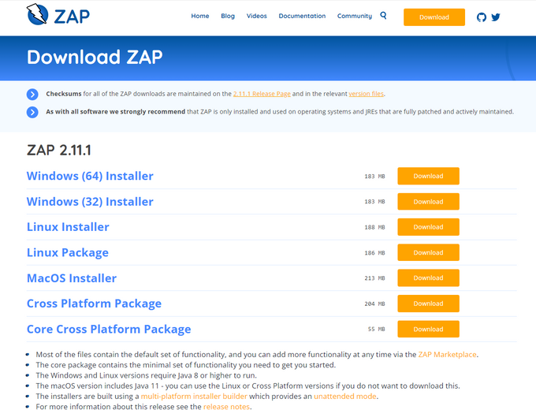
Step-2: Launch OWASP ZAP
Open OWASP ZAP after installation and wait for the application to load.
Step-3: Create and Save a Session
Select Persist Session when prompted, provide a suitable session name and location, and click Save to save the testing session.
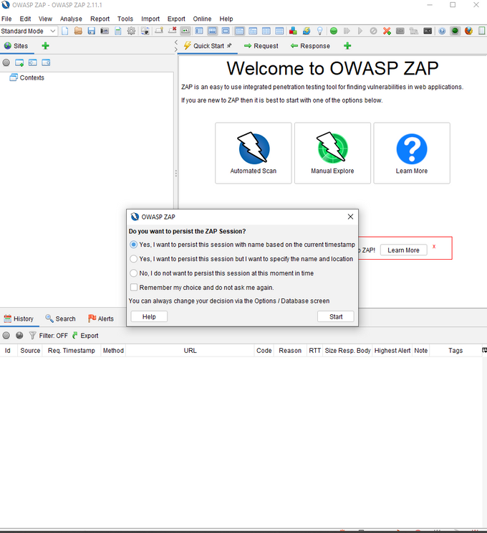
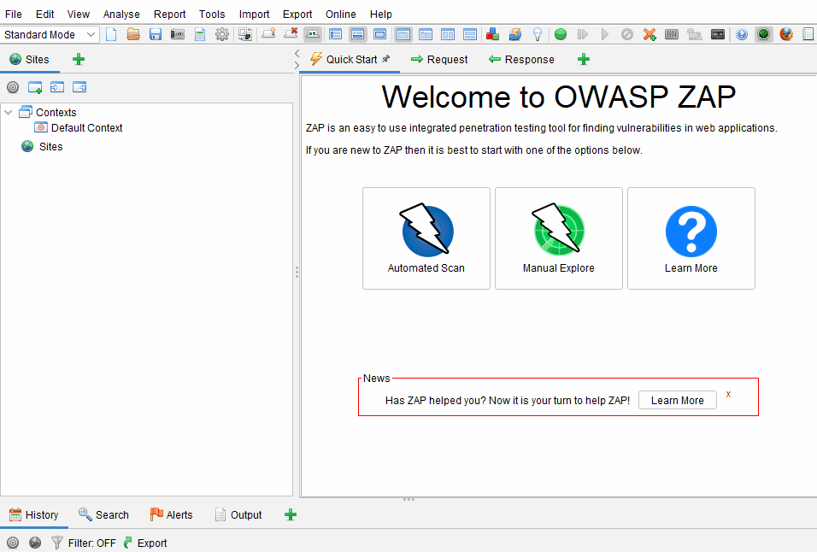
Step-4: Enter the Target URL
Open the Quick Start tab, select Automated Scan, and enter the URL of the authorized web application in the URL to attack field.
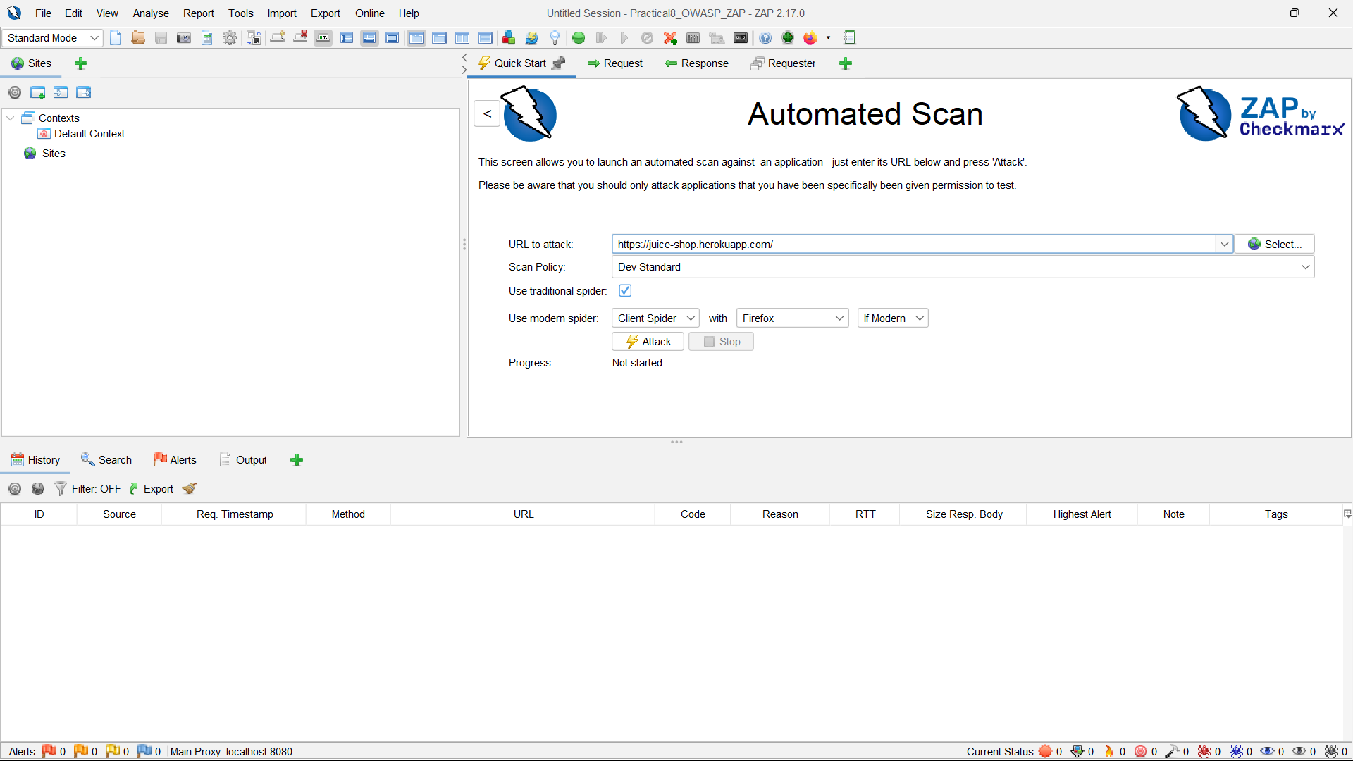
Step-5: Start the Automated Scan
Click Attack! to start the automated scan; ZAP will crawl the target application and analyze its responses for common security vulnerabilities.
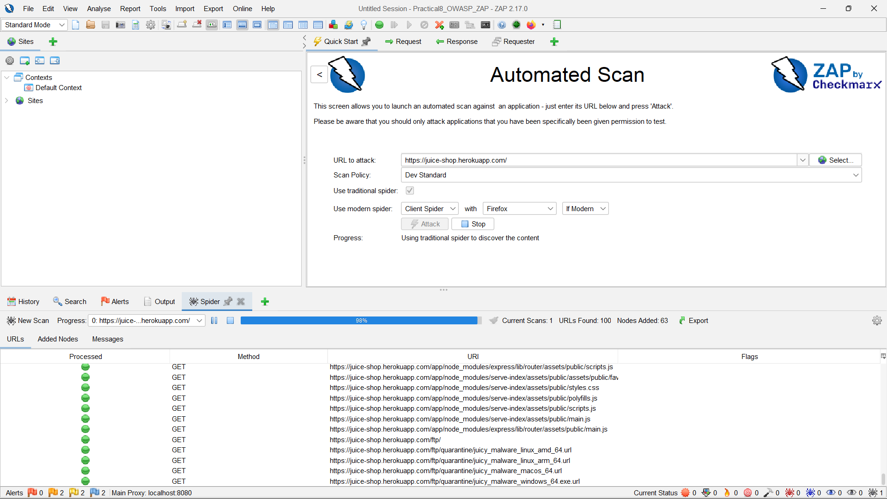

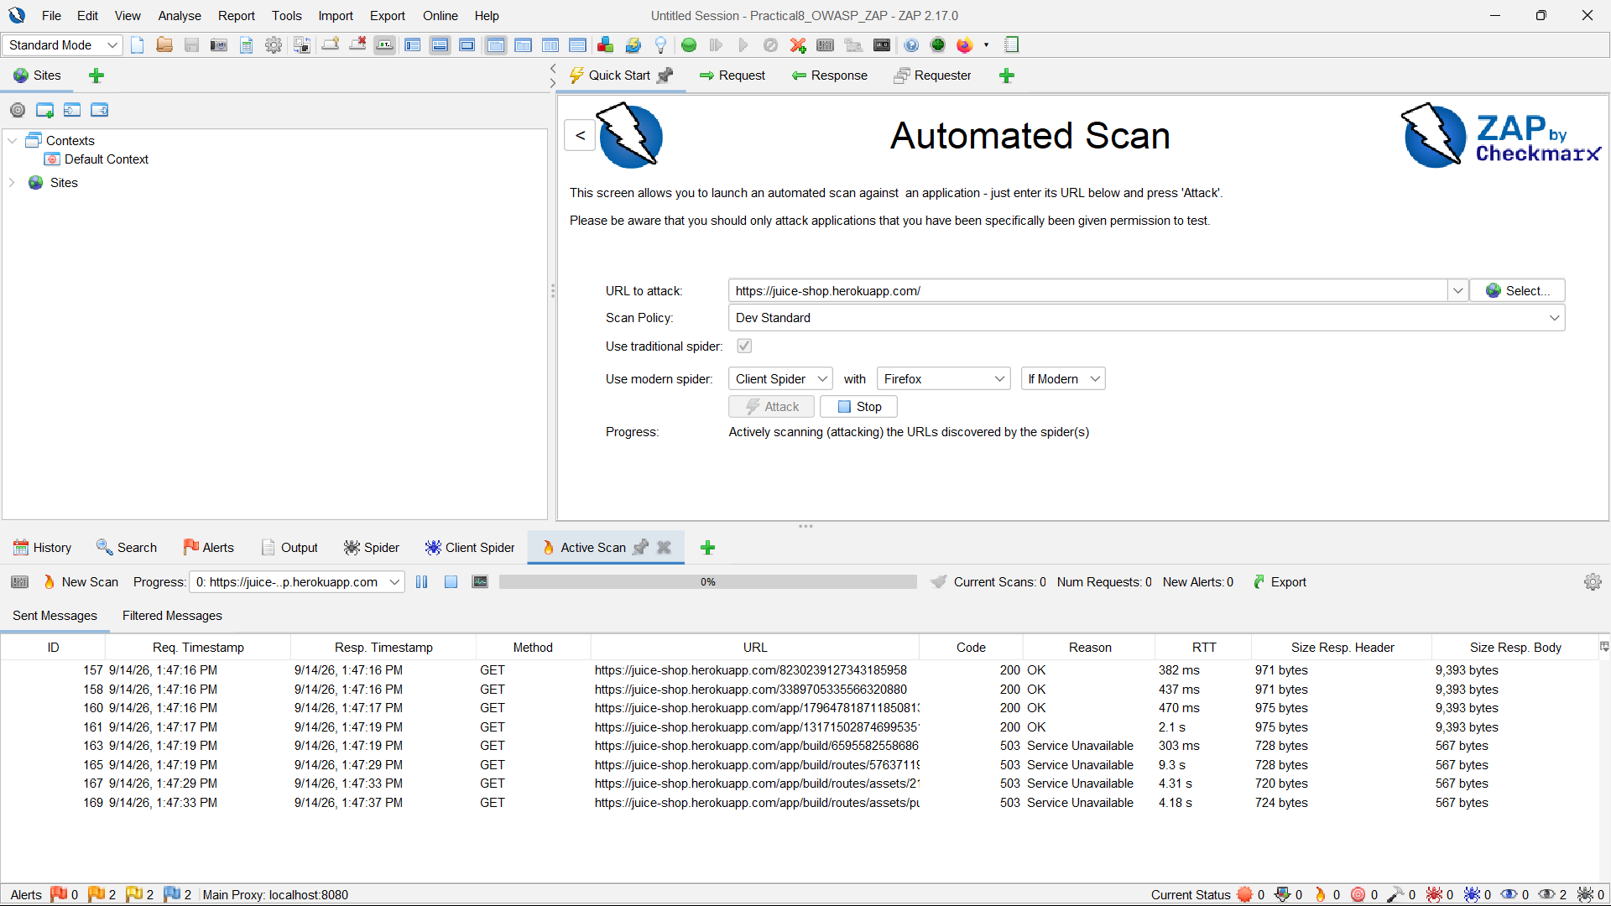
Step-6: Monitor the Scan
Observe the Sites, Alerts, and other panels while the scan is running to track the URLs discovered and potential security issues.
Step-7: Open the Alerts Panel
After the scan completes, open the Alerts tab to view the security issues identified by OWASP ZAP.

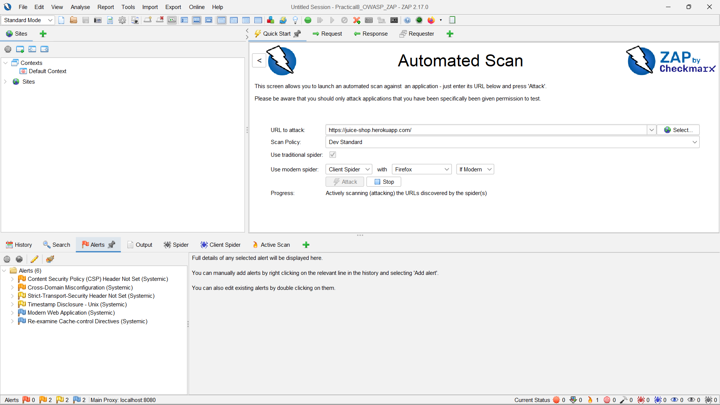

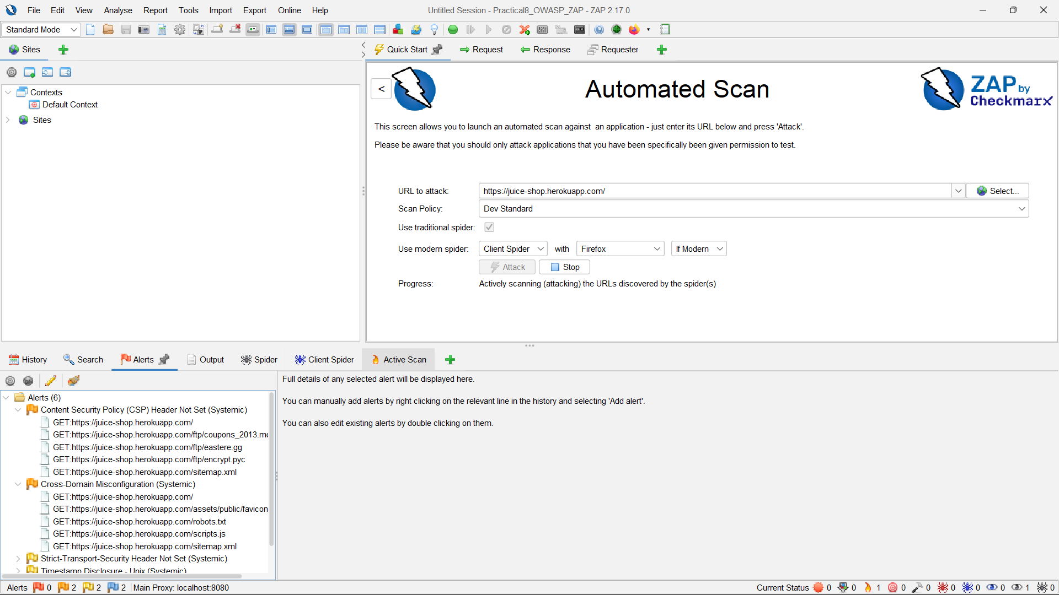
Step-8: Analyze Alert Risk Levels
Review the alerts according to their severity, such as High, Medium, Low, and Informational, and identify the issues that require further investigation.
Step-9: View Alert Details
Select an individual alert to view its description, affected URL, evidence, risk information, and recommended remediation steps.
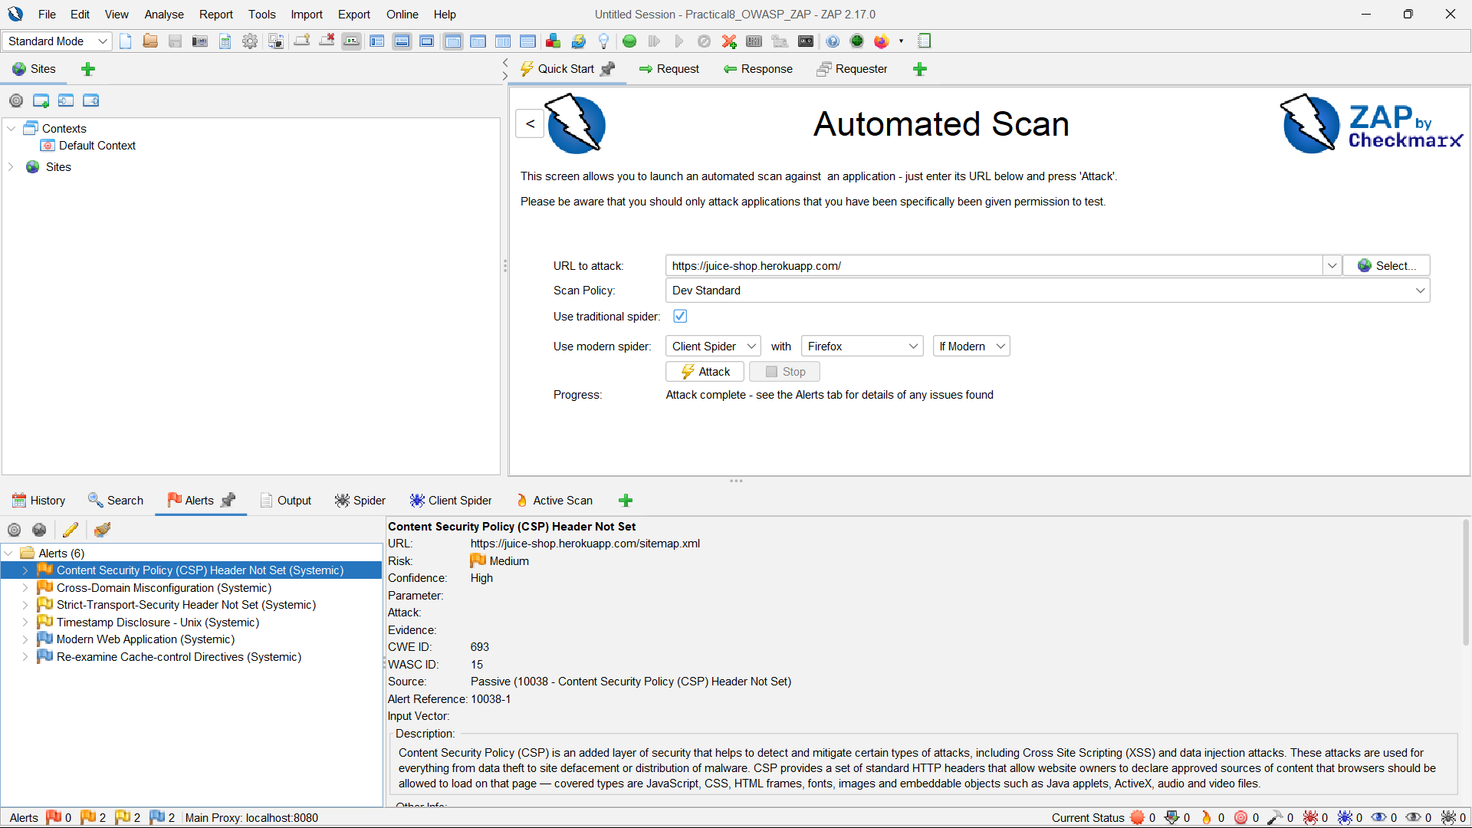
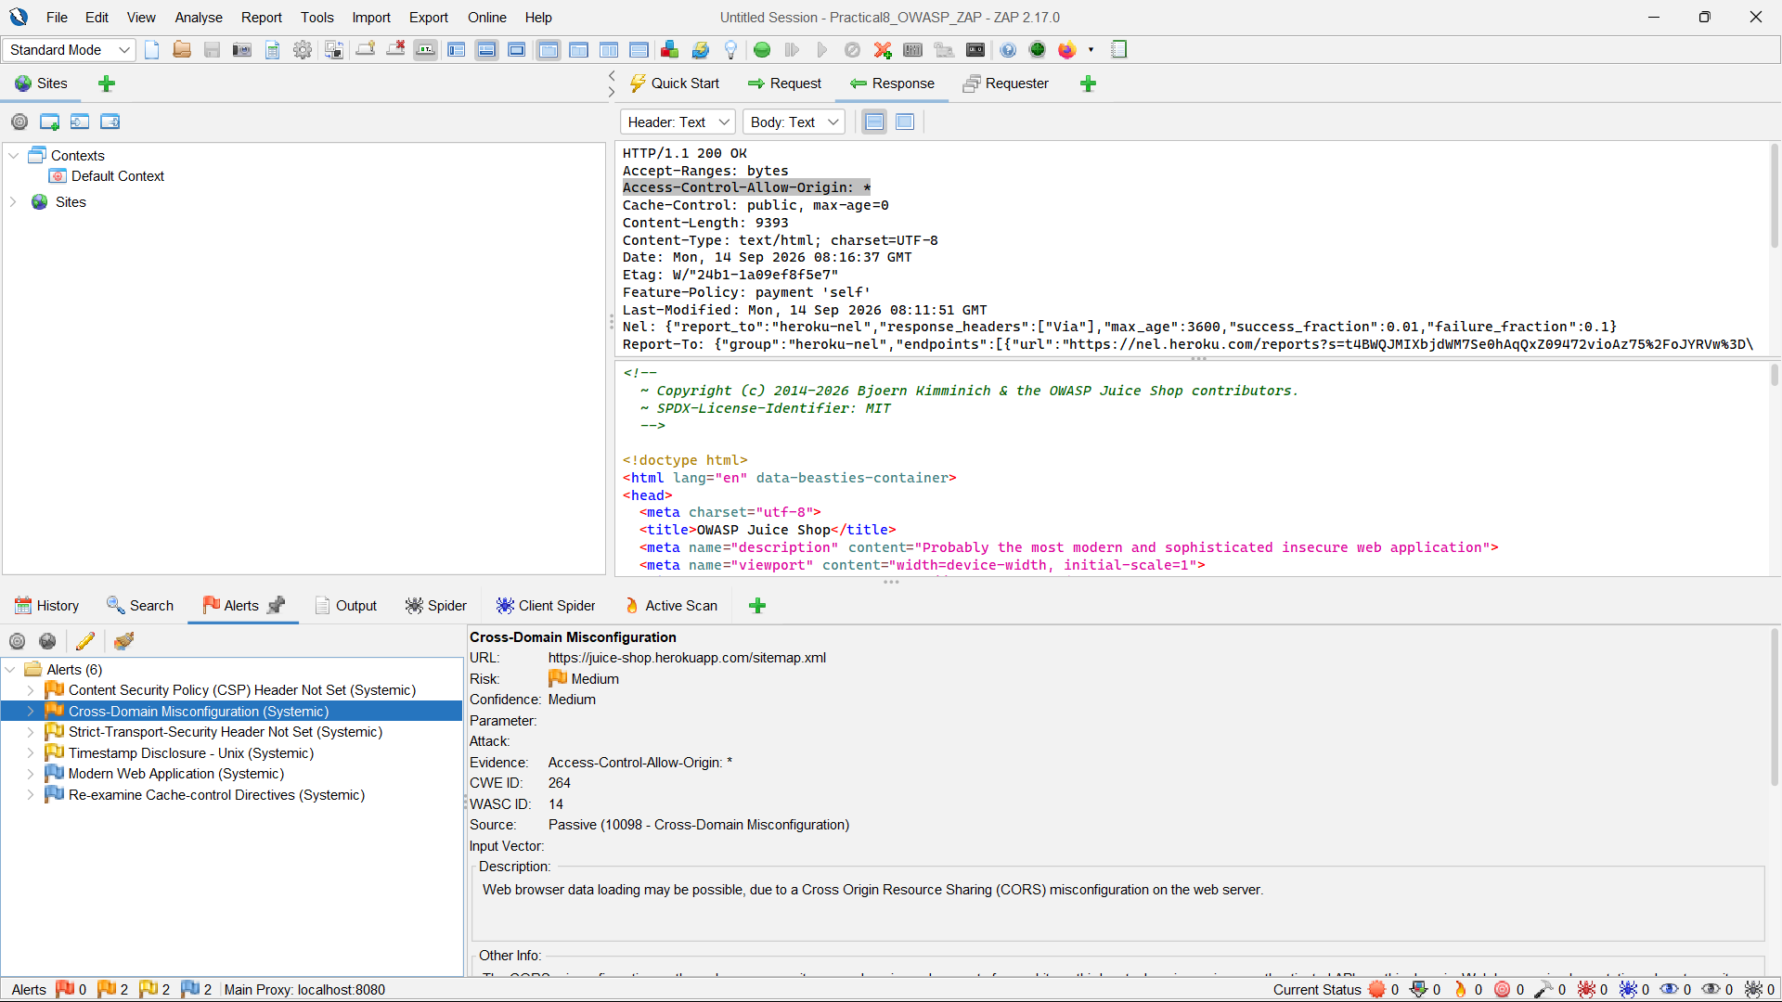
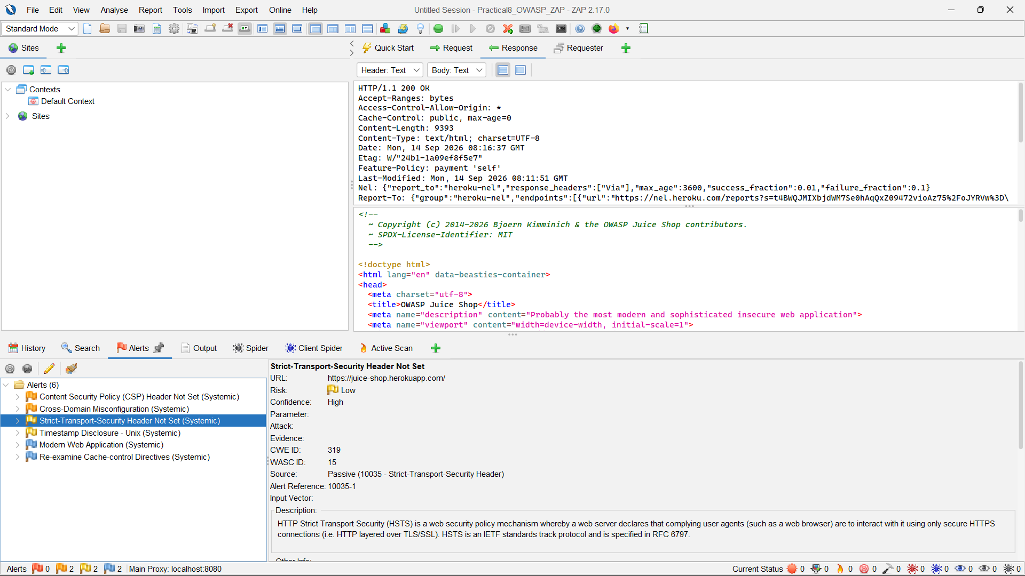

Step-10: Explore the Application Manually
Select Manual Explore, choose the available browser, and browse the authorized application through the ZAP proxy to identify issues that may not have been detected automatically.
Step-11: Monitor Manual Testing Alerts
While navigating the application, monitor the Alerts panel for newly detected security issues and review their details.
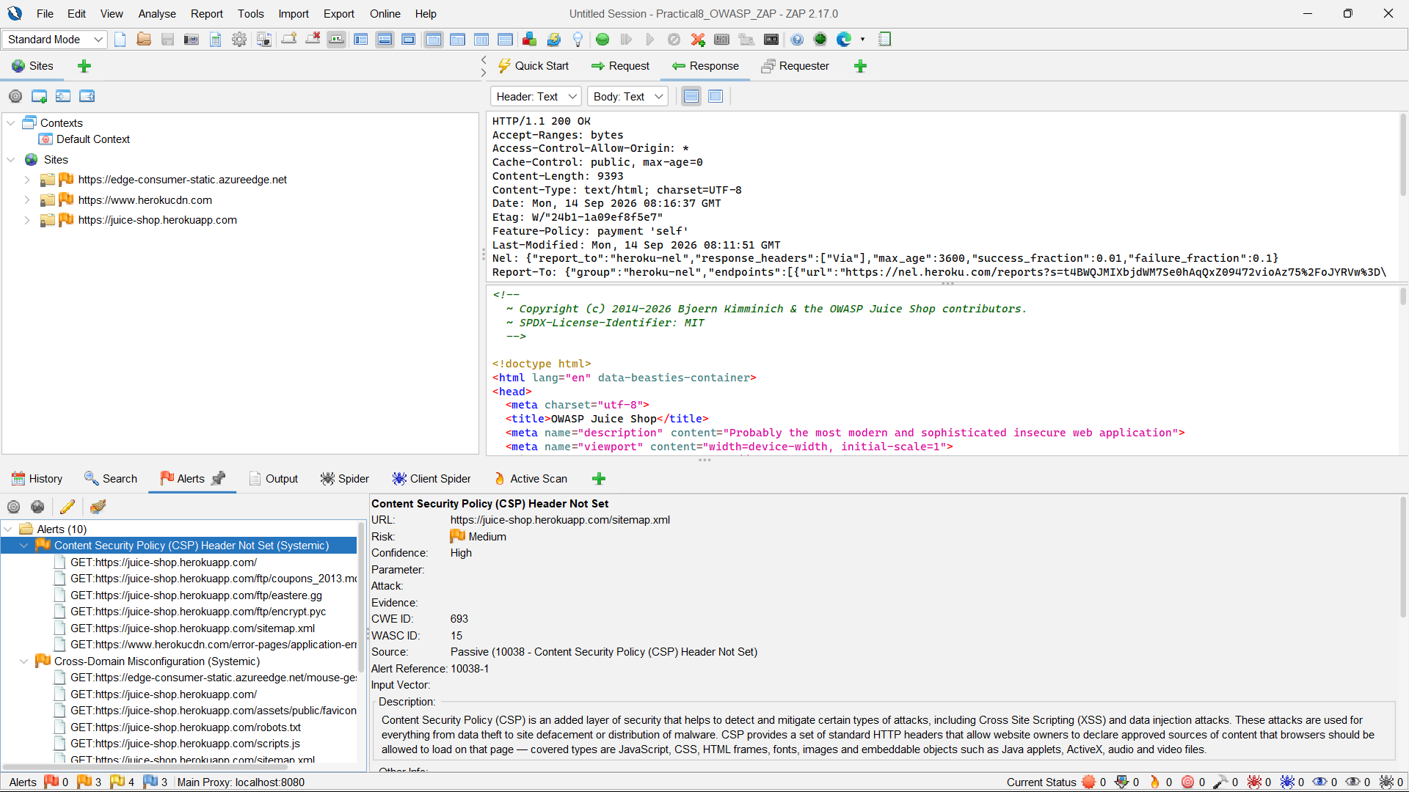
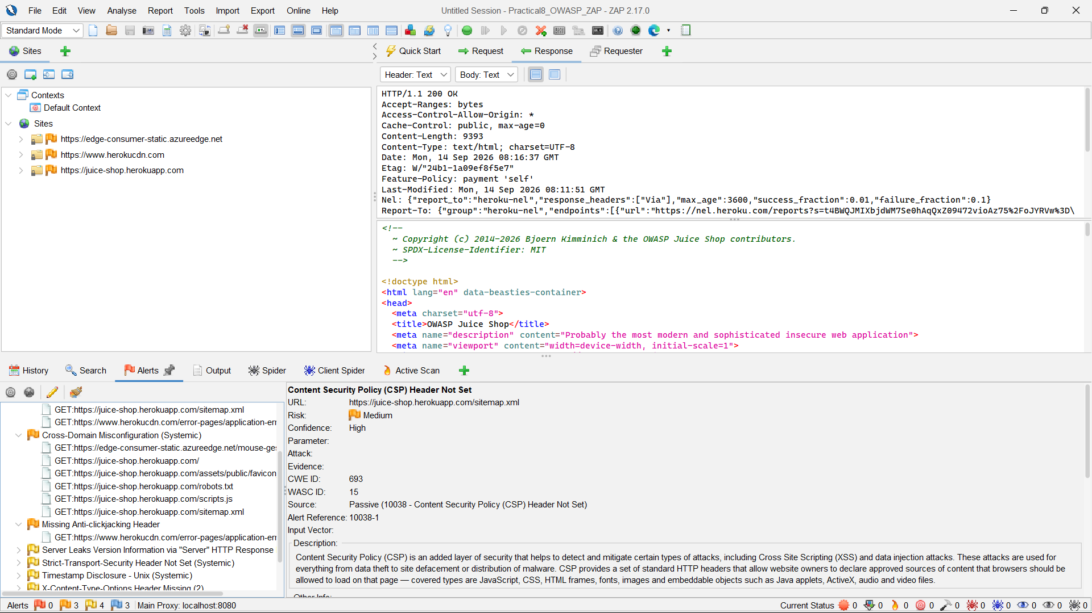
Step-12: Save the Testing Session
Save the ZAP session again after completing the automated and manual testing so that the results can be reviewed later.
Tutorial | https://www.youtube.com/watch?v=ezxBkFhKXhw

